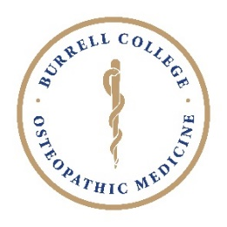
Burrell College of Osteopathic Medicine
2021 Medical Student Research Day
Burrell, Las Cruces, New Mexico
July 16, 2021

Abstract Form

Students wishing to submit an abstract for the 2021 Medical Student Research Day must complete and submit this form no later than July 8, 2021, at 11:59 PM. Please read all instructions found within the Abstract Submission Guidelines before you begin your submission and ensure your abstract conforms to the instructions provided. Please note that all fields must be completed for the abstract to be considered. Abstracts will be published in the MSRD Event Program; therefore, they must comply with the format described in the Abstract Submission Guidelines. Abstracts are limited to a single page.

All abstracts must be created using this “Abstract Form” and submitted online through the Qualtrics Abstract Submission Form by clicking on the “Submit an Abstract” button that is available on the MSRD web page.

only completed applications will be considered

Inquiries about the submission process or Medical Student Research Day should be directed to:

Steven J. Ontiveros, MBA, PhD
Associate Professor, Department of Anatomy & Cell Biology
Director of Student Research, Office of Research & Sponsored Programs
Office Room Number: 321
Office Phone: (575) 674-2331
Direct Email: sjontiveros@burrell.edu
Research Office Email: research@bcomNM.org

Research Category:
☐ Biomedical ☐ Clinical/OMT ☐ Medical Education ☐ Population/Public Health

Faculty Advisor(s): Click or tap here to enter text.

Presenting Authors:
Student Presenter #1:
Full Name: Click or tap here to enter text.

Email: Click or tap here to enter text.

Phone: Click or tap here to enter text.

Student Presenter #2:
Full Name: Click or tap here to enter text.

Email: Click or tap here to enter text.

Phone: Click or tap here to enter text.

Student Presenter #3:
Full Name: Click or tap here to enter text.

Email: Click or tap here to enter text.

Phone: Click or tap here to enter text.

Note: You may add additional student presenters as necessary.

Title: In all caps.
Click or tap here to enter text.

Authors: List all authors in corresponding order including affiliations. Please denote affiliations with superscripts.
Click or tap here to enter text.

Affiliations:
Click or tap here to enter text.

Abstract:
Click or tap here to enter text.

